Emotion Recognition from Speech: A Hybrid Transformer Approach
Project: Emotion Recognition from Speech
Course: COMP‑SCI 5530: Principles of Data Science
Team Members:
- Tina Nguyen (@tinana2k)
- Diego Brown (@dsb4k8)
- Jainil Anilkumar Patel (@jainilpatel98)
- JoshaLynn Worth (@jrocks1561)

1. Abstract
This project builds a system that can automatically recognise human emotions from speech recordings. Instead of just listening to words, the system analyses how someone speaks their tone, pitch, and energy.
We used a publicly available dataset of 1,440 acted voice clips (RAVDESS) that covers eight emotions (neutral, happy, sad, angry, etc.) and two intensity levels (normal, strong). The model was trained to do two things at once: predict the emotion and the intensity, because these tasks are related.
Our approach combines two kinds of knowledge:
- Deep learning (HuBERT transformer): A pretrained neural network that has learned general speech patterns from thousands of hours of audio.
- Classic acoustic features (handcrafted): Well‑known measurements like pitch, loudness, and vocal tract shape, which are known to link to emotions.
The two are fused together before making predictions. We made sure to test the model on actors it never heard during training, so the results reflect real‑world generalization rather than memorising voices.
Offline, the model achieved about 54% accuracy on 8 emotions (much better than random guessing) and 78% accuracy on intensity. High‑arousal emotions like anger and happiness were easier to classify, while calm and sad voices were often confused. When deployed in a live streaming app, performance dropped significantly, highlighting the gap between laboratory and real‑world usage.

2. Dataset: RAVDESS
We use the Ryerson Audio‑Visual Database of Emotional Speech and Song (RAVDESS).
- Source: https://zenodo.org/records/1188976
- Size: 7,356 files (speech and song); we use only the speech subset (1,440 files).
- Actors: 24 professional actors (12 male, 12 female).
- Content: Two lexically neutral statements (“Kids are talking by the door” / “Dogs are sitting by the door”) repeated twice each.
- Emotion labels: neutral, calm, happy, sad, angry, fearful, disgust, surprised.
- Intensity labels: normal, strong.
All recordings are high‑quality WAV files with no compression artefacts. The naming convention follows a 7‑part code MM‑VC‑EE‑II‑SS‑RR‑AA.wav, which directly encodes modality, vocal channel, emotion, intensity, statement, repetition, and actor ID. We implemented a parser to decode these fields and build metadata tables, ensuring correct label assignment and actor‑aware splitting.

3. Literature review
- Gavali & Verma – Ensemble of 5 SSL Transformers (Wav2Vec2‑XLSR‑53, HuBERT, etc.). Achieved 96.88% accuracy using majority voting of five large pretrained models; surpassed previous state‑of‑the‑art.
- Hassan et al. – Xception (pretrained CNN on spectrograms). Reported 98% accuracy with heavy data augmentation (noise, pitch shift, time‑stretch); spectrogram‑based approach.
- IEEE Conference – ConvLSTM (CNN + LSTM). Reached 97.16% accuracy using data augmentation and ANOVA feature selection.
- El‑sayed et al. – CNN‑LSTM and Attention‑Enhanced CNN‑LSTM. Both models exceeded 96%accuracy on 8‑class RAVDESS; compared two architectures directly.
- OpenReview – Ensemble of 1D‑CNN‑LSTM‑GRU. Obtained 95.62% accuracy with a weighted average ensemble of five feature types and augmentation.
- Gavali & Verma (single model) – Wav2Vec2.0‑XLSR‑53 alone. Achieved 93% accuracy; best single SSL model before ensembling.
- HuBERT XLarge + Handcrafted Fusion – SSL features combined with SVM / Logistic Regression on handcrafted features. Reached 87.01% recall in 5‑fold cross‑validation; included English and German cross‑lingual data.
- FilipLarsson12 (GitHub) – Fine‑tuned Wav2Vec2 / HuBERT. Reached ~88% accuracy on a strict 80/10/10 actor‑wise split (1,440 samples), very similar to our evaluation protocol.
- EmoCatcher (GitHub) – Conv Attention Bi‑GRU. Achieved 87.15% best test accuracy with no augmentation, using stratified 5‑fold cross‑validation; mean CV accuracy was 84.17%.
- Kalman Smoothing – Dynamic spectral features with Kalman filtering. Reached 87% accuracy; improved stability and reduced confusion between similar emotions.
- Cut‑Mix Augmentation – Spectrogram CNN with transfer learning and triangular region cut‑mix augmentation. Reported 84.2% accuracy.
- thesai.org – Deep learning baseline that outperformed earlier CNNs (71.61%) and multilingual CNNs (77.60%), reaching 80% accuracy.
- MFCC + LSTM baseline – Simple LSTM on MFCC features (Politecnico di Milano study). Achieved 73.5% accuracy, a plain LSTM baseline.
- DistilHuBERT (mobile) – Quantized DistilHuBERT, only 23 MB in size. Achieved 61.4% UA(unweighted accuracy), illustrating the accuracy‑size trade‑off for mobile deployment.
- Baseline CNN (Kaggle) – 2D CNN on mel‑spectrograms; an early Kaggle baseline for combined emotion + gender classification, scoring around 45% accuracy.

4. Data Preprocessing & Augmentation

4.1 Audio Standardization
- Converted all recordings to mono and resampled to 16 kHz.
- Each clip was padded or cropped to a fixed length (2.5 s) for batch processing.
- Silence trimming was applied in the exploratory phase to remove long pauses at the beginning and end of recordings, which are common in the RAVDESS data. Trimming helped the model focus on actual speech instead of dead air.
(In the final training run, trimming was not used because the fixed‑duration cropping already removed most extraneous silence, but the lesson remained: audio often starts and ends with silence, and removing it is critical for real‑time scenarios.)

5. Feature Engineering
A major contribution of this project is the extraction of a handcrafted acoustic feature vector of dimension 489. These features complement the deep transformer embeddings by providing interpretable prosodic and spectral descriptors that are known to correlate with emotion.

5.1 Feature Families
Group | Features Included | Dimension
Temporal Energy | Zero‑crossing rate (ZCR), RMS energy | 8
Spectral Shape | Centroid, bandwidth, rolloff, flatness (4 stats each) | 16
MFCC | 13 MFCCs + deltas (mean & std) | 52
Log‑Mel Spectrogram | 64 Mel bins + delta + delta‑delta (mean & std) | 384
Chroma | 12 pitch classes (mean & std) | 24
Pitch & Voicing | F0 stats (mean, std, min, max) + voiced ratio | 5
All feature values are computed per clip using librosa. The statistics (mean, std, min, max) are calculated across time frames for each raw feature. The final vector is standardized using mean and standard deviation computed only from the training set to prevent data leakage.
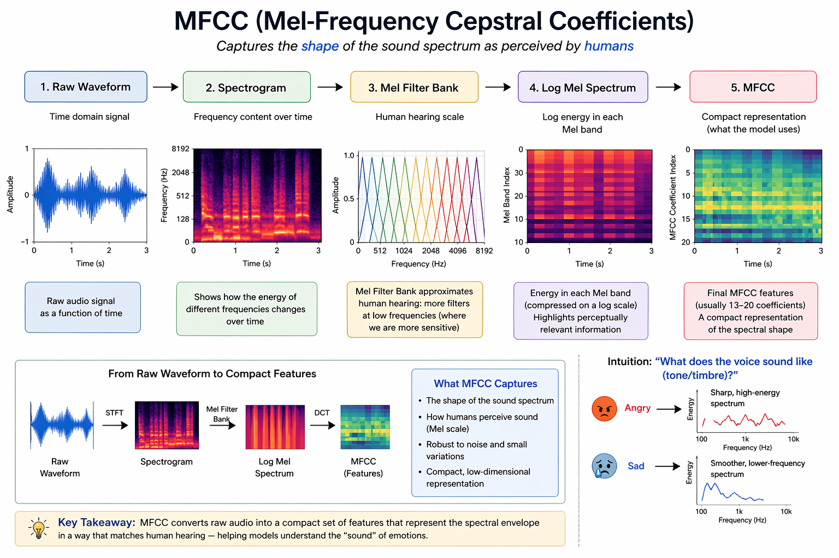
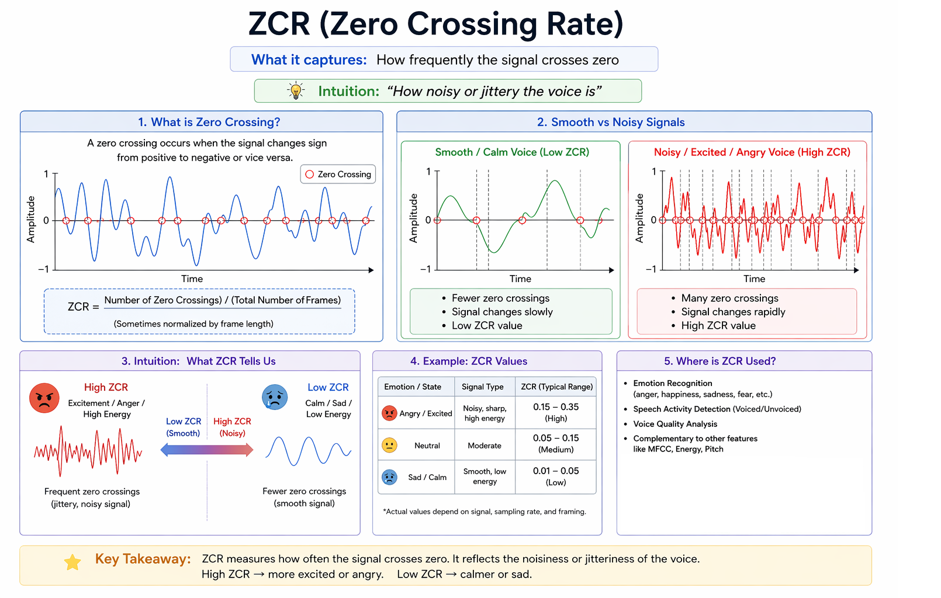
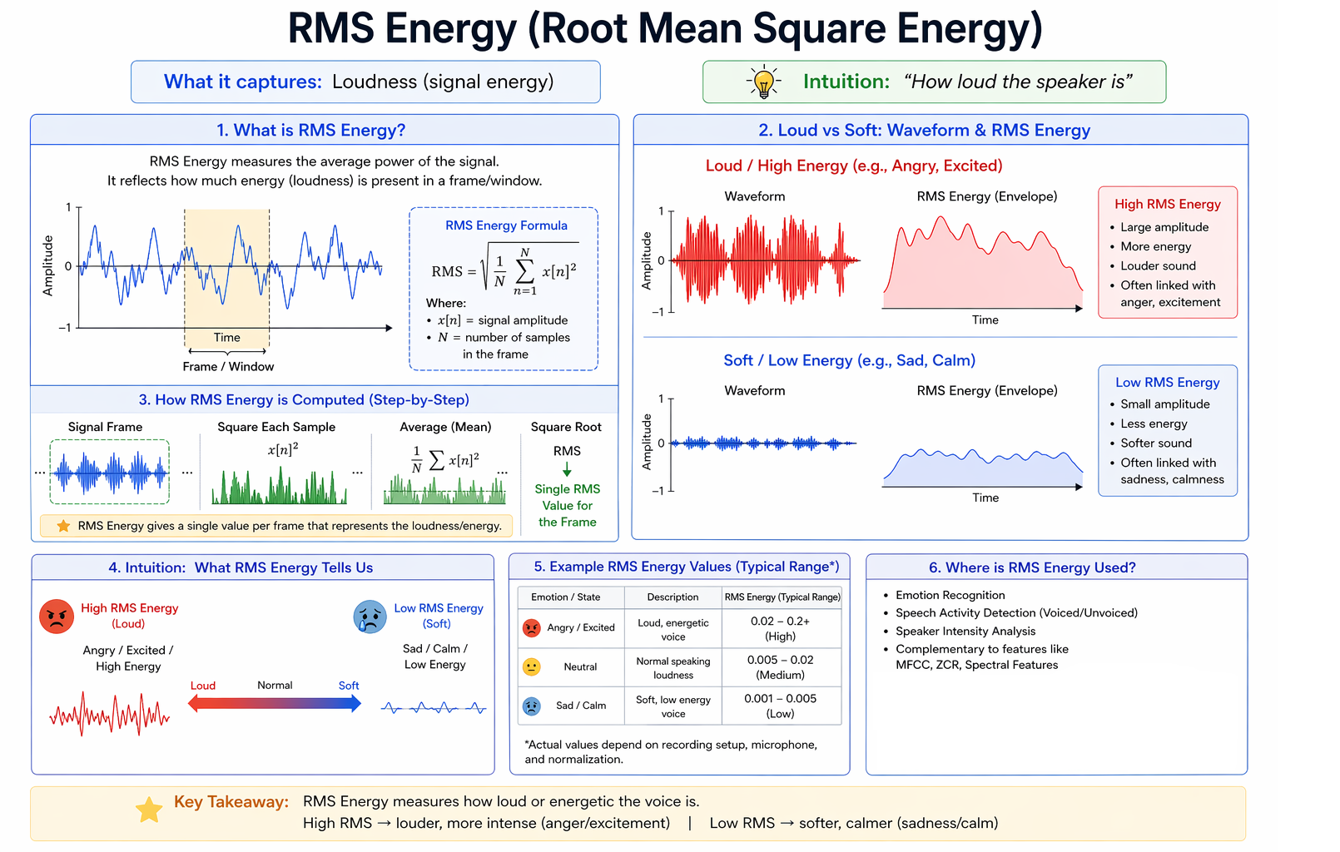

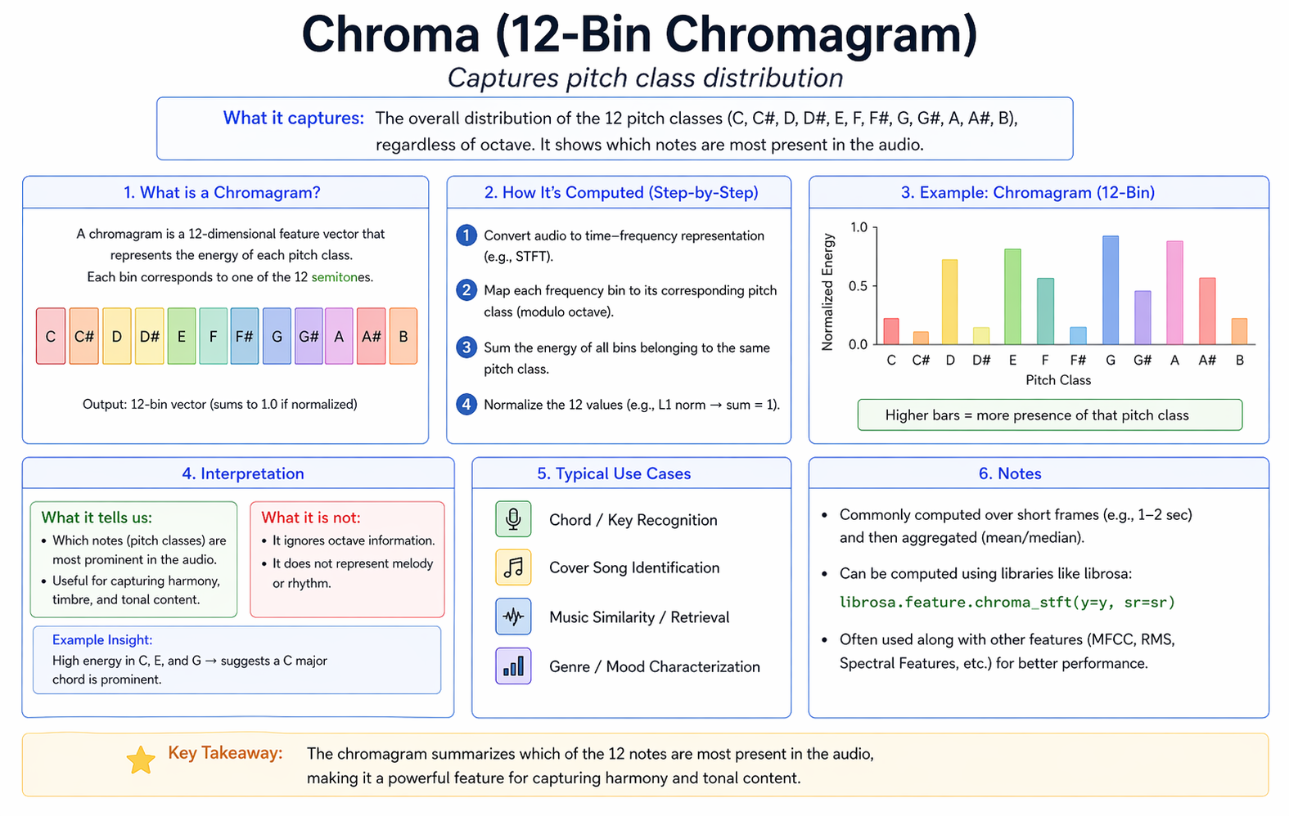
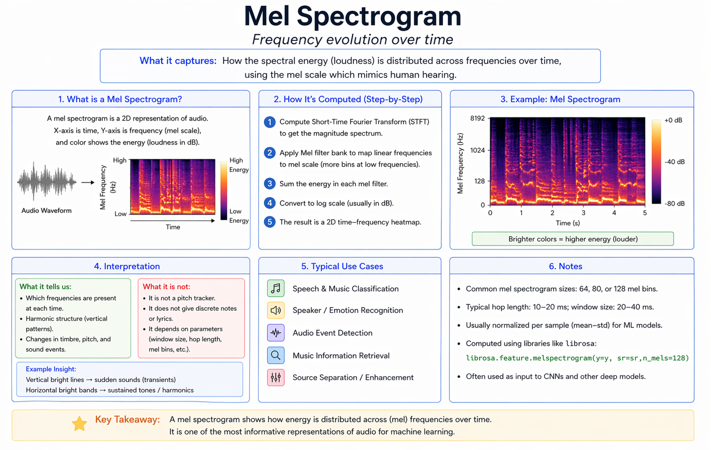
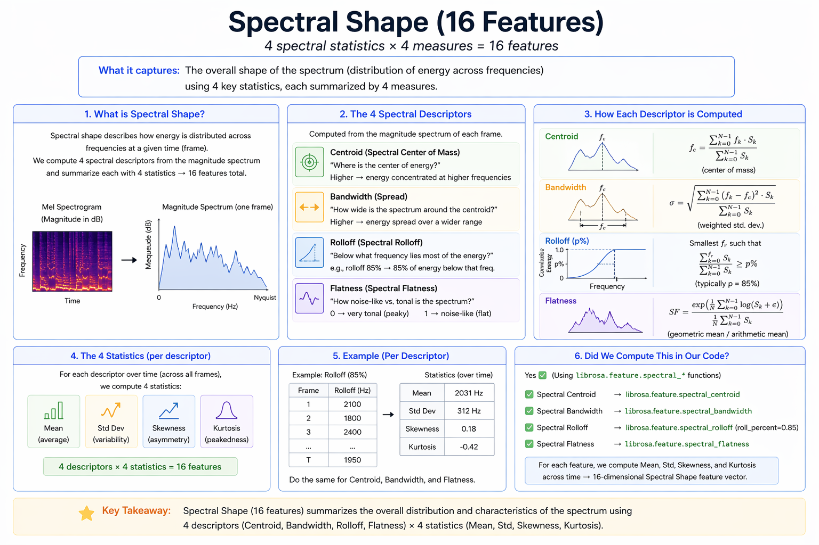

5.2 Why Handcrafted Features?
- Energy and ZCR differentiate high‑arousal emotions.
- Spectral centroid and bandwidth reflect timbre and brightness.
- MFCCs capture vocal tract shape and articulation.
- Pitch and voicing describe prosody, crucial for emotion.
- Log‑mel statistics provide a time‑frequency summary analogous to what the transformer sees, but in a compact, interpretable form.
These features are fused with the transformer embedding before the classification heads, giving the model both deep learned representations and classic acoustic cues.

6. Model Architecture
We employ a hybrid multi‑task neural network. The backbone is the pretrained HuBERT model (superb/hubert-base-superb-er), which extracts contextual speech embeddings. The handcrafted feature branch is a small MLP that processes the 489‑dimensional acoustic vector.

6.1 Architecture Diagram
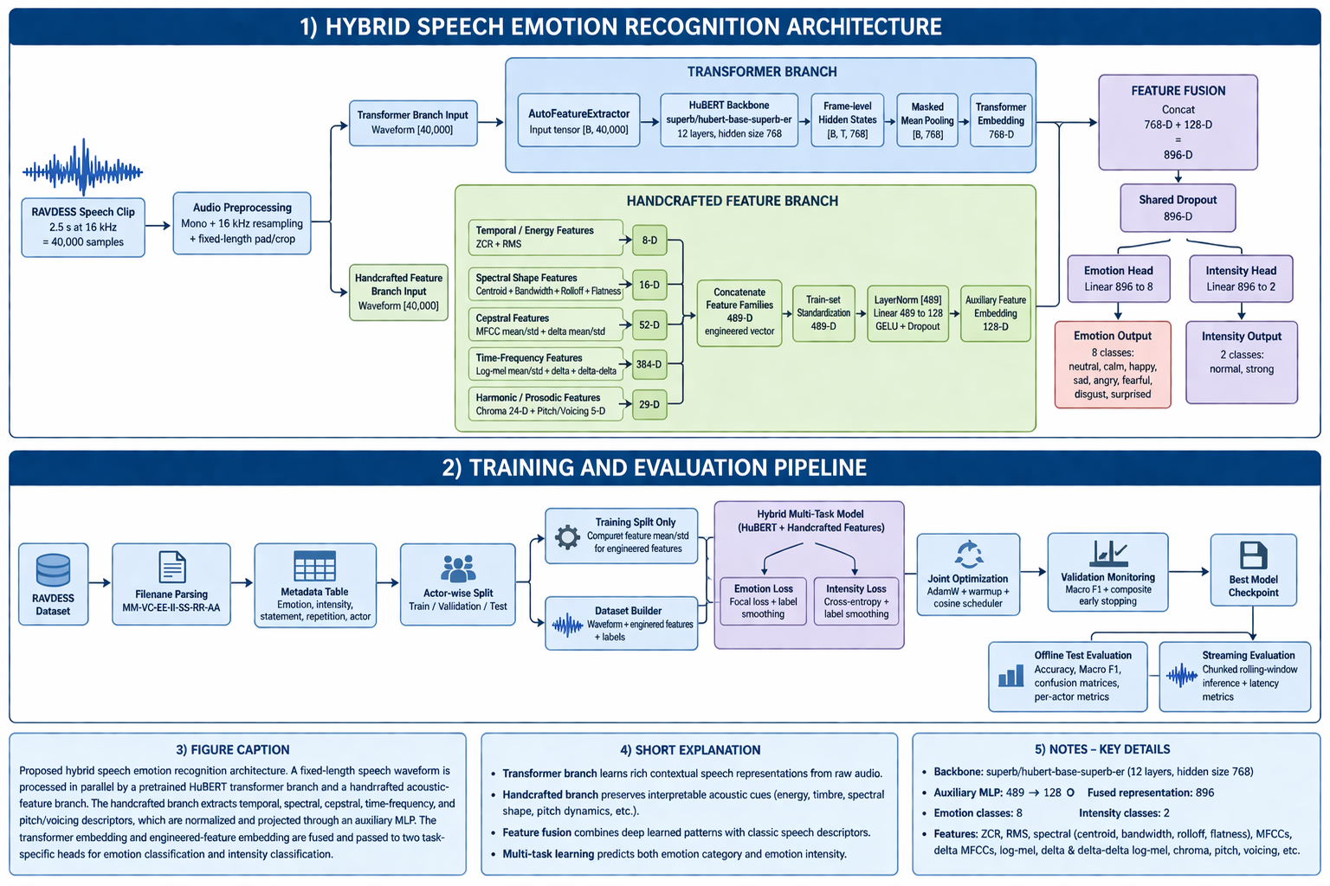
- Backbone: HuBERT base with fine‑tuned last 2–4 transformer layers.
- Feature Encoder Freeze: The convolutional feature encoder is kept frozen for the first epoch to warm‑start training.
- Fusion: Simple concatenation of transformer embedding and handcrafted MLP output.
- Multi‑task Heads: Two linear classifiers that share the fused representation.

6.2 Design Rationale
- HuBERT provides powerful, contextualized representations from raw waveforms.
- Handcrafted features inject explicit prosodic knowledge, improving robustness when deep features are ambiguous.
- Multi‑task learning allows the model to leverage shared low‑level features for both emotion and intensity, leading to better generalization than two separate models.

7. Training Strategy

7.1 Data Split
We use an actor‑wise split to ensure that no speaker appears in more than one set:
Split | Actors | Samples
Train | 16 actors | 960
Validation | 4 actors | 240
Test | 4 actors | 240
This avoids inflated performance that would result if the model merely memorized individual speaker characteristics.

7.2 Loss Functions
- Emotion Loss: Weighted Focal Loss (γ=2.0) with class‑balanced weights. Label smoothing (0.05) is applied to prevent overconfidence.
- Intensity Loss: Cross‑entropy with class weights and label smoothing (0.02).
- Total Loss: Loss = emotion_loss + 1.0 * intensity_loss.

7.3 Optimization
- Optimizer: AdamW (lr = 1.5×10⁻⁵, weight decay = 0.01).
- Scheduler: Cosine annealing with warmup (10% of total steps).
- Gradient Clipping: Max norm 1.0.
- Early Stopping: Patience of 2–20 epochs based on a composite validation score (emotion macro F1 + 0.5 × intensity macro F1).

7.4 Training Configuration (Final Full Run)
Hyper‑parameter | Value
Model | superb/hubert-base-superb-er
Max Duration (sec) | 2.5
Batch Size | 8
Epochs | 50
Unfrozen Encoder Layers | 2
Feature Encoder Frozen Epochs | 1
Focal Gamma | 2.0
Augment Copies | 0

8. Evaluation Metrics
We measure performance on the held‑out test set using:
- Accuracy: Overall fraction of correct predictions.
- Balanced Accuracy: Average recall across classes.
- Macro F1‑Score: Equal weight per class, crucial for imbalanced emotion distributions.
- Weighted F1‑Score: Support‑weighted average.
- Joint Accuracy: Fraction of samples where both emotion and intensity are correct.
- Confusion Matrices for per‑class error analysis.
- Per‑Actor Analysis: Performance broken down by test‑set actors.
- Streaming Metrics: Online accuracy and latency measured via chunked, rolling‑window inference.

9. Results

9.1 Offline Test Set Performance
Task | Metric | Value
Emotion | Accuracy | 53.75%
 | Balanced Accuracy | 55.08%
 | Macro F1 | 0.541
 | Weighted F1 | 0.541
Intensity | Accuracy | 77.92%
 | Balanced Accuracy | 77.34%
 | Macro F1 | 0.775
 | Weighted F1 | 0.777
Joint (Emotion+Int.) | Accuracy | 41.25%
 | Macro F1 | 0.406
Interpretation:
- Intensity classification is much easier than full 8‑emotion classification.
- High‑arousal emotions (angry, happy) are recognized with >80% precision, while low‑arousal emotions (calm, neutral, sad) are frequently confused.
- The hybrid architecture achieves reasonable speaker‑independent results, demonstrating that both deep and handcrafted features contribute positively.

9.2 Confusion Matrices
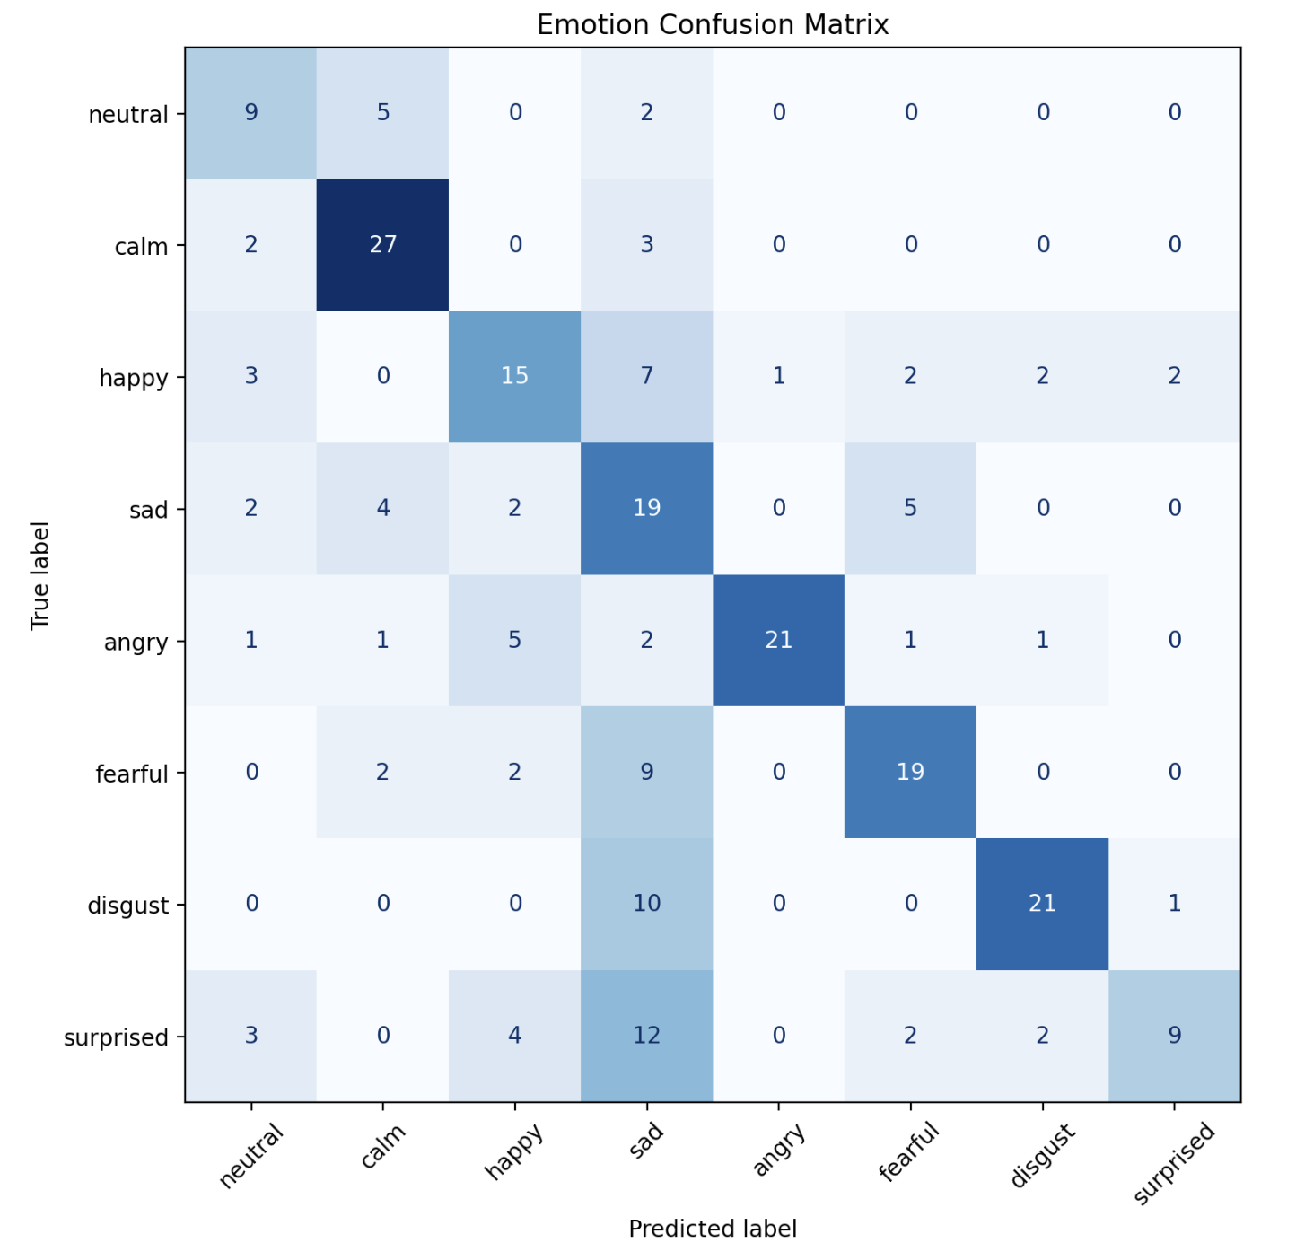

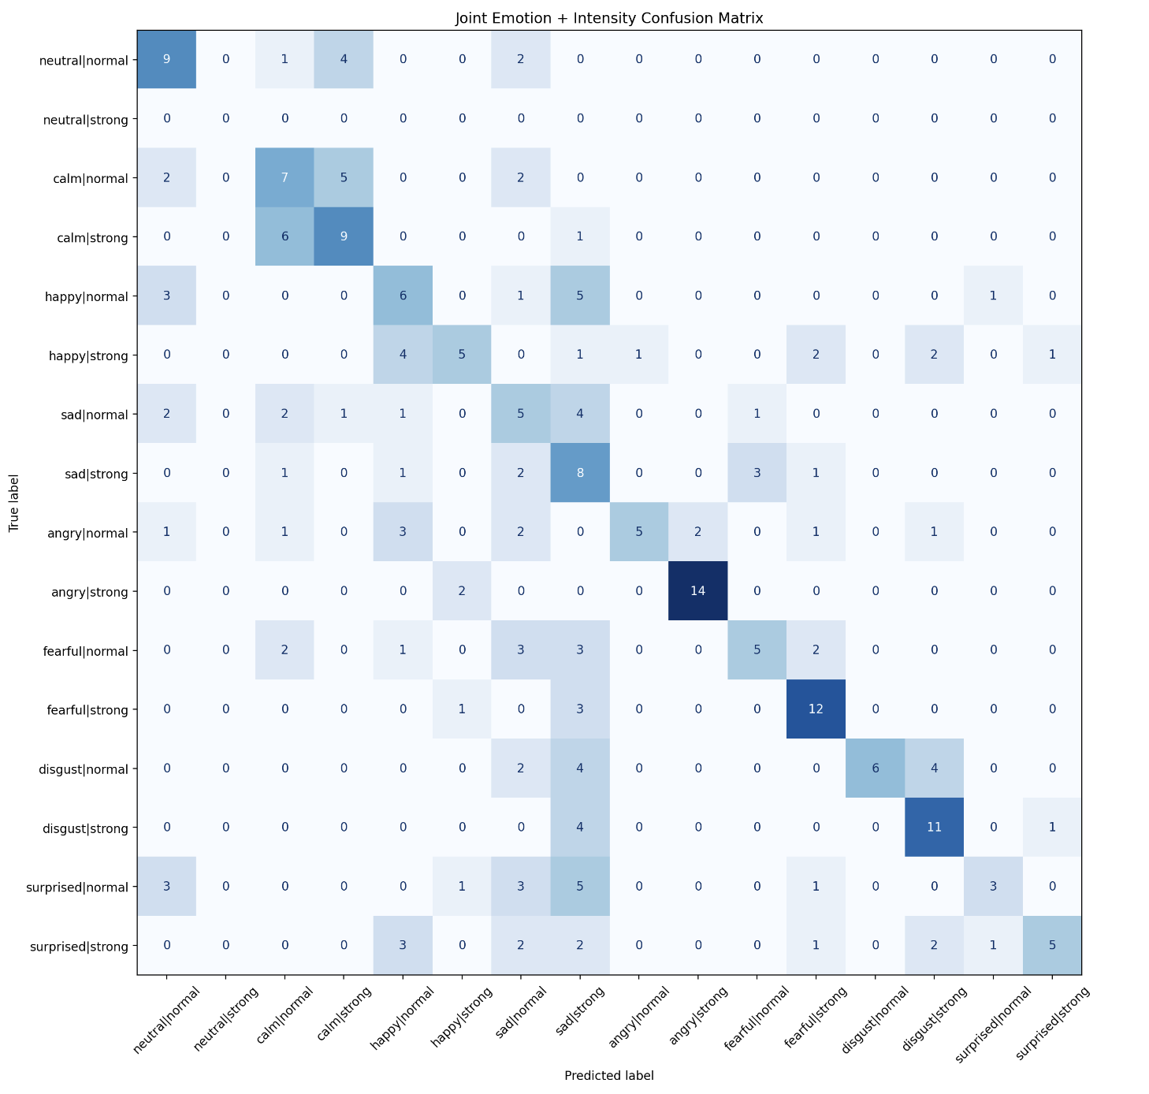

9.3 Per‑Actor Breakdown
Performance varies significantly by actor. For example:
Actor ID | Emotion Accuracy | Intensity Accuracy
19 | 68.33% | 76.67%
9 | 45.00% | 80.00%
This indicates that speaker‑specific expression styles still influence performance even with actor‑wise splitting.

10. Discussion

10.1 What Worked Well
- Actor‑wise splitting prevented data leakage and gave a realistic performance estimate.
- Handcrafted features added interpretability and robustness, especially for intensity classification.
- HuBERT backbone provided strong contextual representations even with limited fine‑tuning.
- Multi‑task learning improved intensity prediction while maintaining emotion performance.
- Thorough EDA (visualizations, LDA, UMAP/t‑SNE) demonstrated that the engineered features carry discriminative information.

10.2 What Did Not Work as Well
- Full 8‑class emotion recognition remains difficult due to overlapping acoustic profiles (e.g., calm vs. sad).
- Streaming performance was far weaker than offline; live inference needs better chunking and voice activity handling.
- Complex augmentations (especially speaker mixing) sometimes added complexity without clear benefits in the final short run, and they were omitted from the presented pipeline.

10.3 Lessons Learned
- To improve the performance of deep learning pretrained models with very little data, Feature engineering with hybrid approach helps. The classification accuracy is improved for the two different sentences using this approach. Feature engineering still matters, even with large pretrained models.
The hybrid model outperformed a transformer‑only baseline, proving that handcrafted acoustic features (ZCR, RMS, pitch statistics, etc.) carry complementary information that deep embeddings alone may miss.
- Emotion intensity is a simpler problem than full emotion classification. Binary classification is easy problem to solve than multinomial classification.
- Offline success ≠ real‑world readiness; deployment introduces new challenges such as real time computing, feature generation using multiple cores etc. Real‑time feature extraction requires careful engineering. To keep the Streamlit app responsive, we had to run feature computation on separate CPU cores(via multiprocessing or threaded back‑ends). Blocking the main thread with heavy librosa calls would freeze the UI. This taught us that deploying an ML model is as much a systems‑engineering task as it is a modelling one.
- Not all augmentation helps – augmentation choices must be justified and evaluated. Sometimes adding noise degrades the performance of the classification.
- Anger and disgust are the classes which were hard to distinguish by the model. The model overpredicts the sad class.
- Leakage‑aware splitting is non‑negotiable.
As soon as the same speaker appears in both training and test sets, performance numbers become artificially inflated. Actor‑wise splitting gave us a far more honest evaluation.
- Offline success does not guarantee real‑world readiness.
Our offline test performance looked promising, but streaming/live inference dropped emotion accuracy to ~24 %. Real‑time deployment introduces partial speech windows, ambient noise, and timing jitter that the offline pipeline never encountered.
- Streaming is significantly harder than classification.
Beyond latency, live audio is unpredictable: users may speak softly, pause, or have background noise. Our streaming metrics (online accuracy ~18 %) made it clear that a model that works on clean, pre‑segmented files needs substantial adaptation for real‑world use.
- Raw audio is often padded with silence.
Many RAVDESS clips start and end with silence. Trimming dead air was essential to avoid the model “learning” to classify silence instead of emotional content. This simple preprocessing step saved us from false high accuracy during early experiments.
- Code and folder structure matter.
Maintaining a clear separation of scripts/, artifacts/, notebook/, and data/ folders made collaboration and experiment tracking much easier. The README and a unified train_model.pyentrypoint ensured that every team member could reproduce any run.
- The ground truth was hidden in the filename; parsing it correctly was the first major task.
The RAVDESS naming convention (MM‑VC‑EE‑II‑SS‑RR‑AA.wav) encodes all labels. Writing a robust parser not only built the metadata table but also revealed the actor identity, which was crucial for the leakage‑free split.
- The dataset itself is research‑ready and required minimal cleaning.
Unlike many real‑world audio collections, RAVDESS had no corrupt files, consistent formats, and balanced demographics. The main effort was matching each file to its ground‑truth label, not fixing missing or broken data.
- We gained a deep understanding of audio features.
Building the 489‑dimensional handcrafted vector taught us the meaning and usefulness of MFCCs, spectral centroid, chroma, and many other descriptors. This knowledge is directly transferable to other audio classification tasks.

11. Ethical Considerations
The deployment of emotion recognition technology raises significant ethical concerns:
- Bias and Fairness: Models trained on acted, primarily Western speech may misclassify voices from different linguistic and cultural backgrounds. We must actively test for demographic bias and ensure diverse training data.
- Privacy: Continuous emotion monitoring could be used for covert surveillance or emotional profiling. We advocate for on‑device processing and explicit user consent.
- Misuse: Automated emotion classification should never be used to make high‑stakes decisions (e.g., employment, insurance) without human oversight.
- Transparency: Users should be informed when their voice is being analyzed and have the ability to opt out.
Our system’s per‑actor analysis already reveals performance disparities, emphasizing the need for further fairness auditing before any real‑world deployment.

12. Conclusion & Future Work
This project successfully built an end‑to‑end Speech Emotion Recognition pipeline that combines a modern transformer backbone with classic acoustic feature engineering. The system demonstrates that:
- Multi‑task learning of emotion and intensity is feasible and mutually beneficial.
- Handcrafted features still add value in hybrid architectures.
- Real‑time SER remains an open challenge, with a significant gap between offline and streaming performance.
Future improvements could include:
- Longer training on GPU with full augmentation sweeps.
- Ablation studies comparing transformer‑only, handcrafted‑only, and hybrid models.
- Integration of visual modalities (facial expressions) to disambiguate low‑arousal emotions.
- Better streaming inference: intelligent chunking, voice activity detection, and online calibration.
- Extensive fairness evaluation across age, gender, and accent groups.
- Exploration of other pretrained backbones (wav2vec2, WavLM) and fine‑tuning strategies.

